Teaching Students Numerical Magnitude across Representations.

Which is more, a quarter pound hamburger sandwich or a third pound hamburger sandwich?

quarter pounder third pounder

Recently, one hamburger chain tried to challenge McDonalds by introducing the third pounder. However, the challenge was a flop. People complained that the third pounder was not a better deal because they did not understand that a third of a pound was more than a quarter of a pound.

Consider this. Is it easier to see which amount is more when it is presented this way?

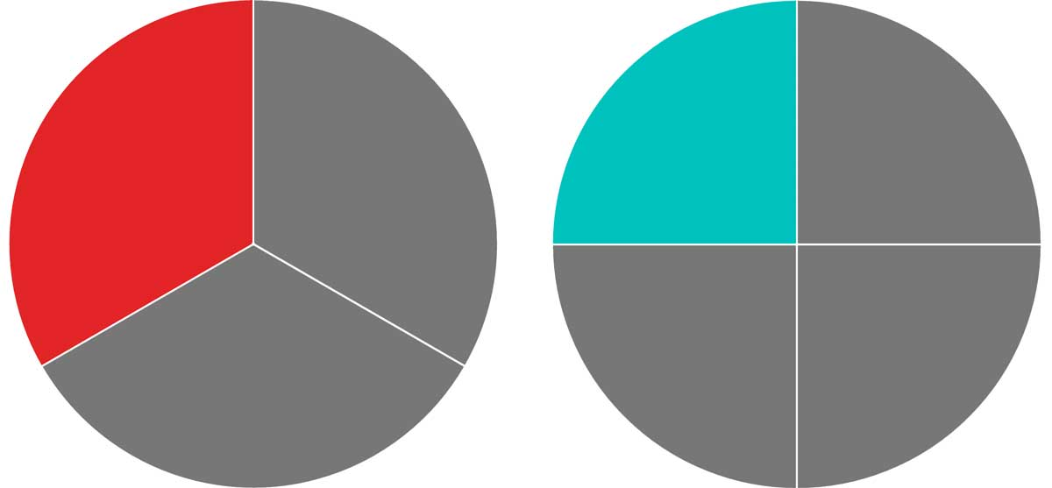

However, many of us were not asked to identify the difference in magnitude of quantities across representations such as pictures, words and number lines. Being able to identify differences in magnitude across representations may lead to deeper understanding of numbers and number relationships.

For the following activity, ask students to identify the larger quantity and how they know for sure. Then, listen to their justifications. Based upon their answers, either correct them if they are incorrect, or restate their answers with additional feed-back if they are correct. Target feedback is the following:

- Benchmarking: eg. “Numbers in the 20’s are bigger than numbers in the teens”
- Number line position: eg. “Any number to the right is larger than any number to the left.”
- Place value: eg. “523 is more than 513, because even though both numerals have the same number of hundreds, twenty-three has one more ten than thirteen, and this makes it larger.”

Ask these questions… Which is more? | Why? How do you know?
2 | 7
36
75 | 50  70
 | 236
524 | 254
50 | 100  0

Key:
=100 units
=10 units
=1 unit

From our article below, here are some number line tasks that you can try. Ask students to identify the missing number and to justify their answer.

For More ideas regarding how to use number lines to build number sense check out our new article.

https://www.jstor.org/stable/10.5951/mtlt.2019.0061?socuuid=9c42e570-1b52-4874-a731-670a7679a52c&socplat=email

Lannin, J., van Garderen, D., & Kamuru, J. (2020) Building a strong conception of the number
line. The Mathematics Teacher, 113 (1), p. 18-24.

