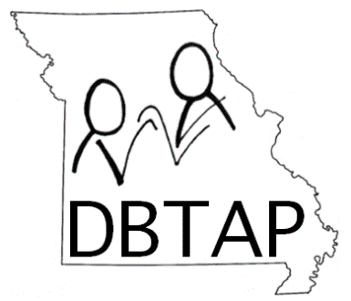

MISSOURI DEAF-BLIND TECHNICAL ASSISTANCE PROJECT
FREQUENTLY ASKED QUESTIONS:

Does reporting a child on this census obligate our school program to provide services such as vision, hearing, orientation and mobility? No. Individualized needs and services are determined by the family and educators through the IEP or IFSP process.

What if I don’t know all the information requested on the form for a particular student? Please refer to the child’s cumulative file if possible and/or the IEP.

Why is the census so important? Funding for specialized services to this population is dependent on having accurate information about how many infants, children and youth in Missouri who have both hearing and vision loss. When the state and national legislatures approve funding—and state and federal agencies allocate the funds—census information is used to determine priorities and needs.

What exactly is meant by the term “deaf-blind”? The MoDBTAP recognizes that this is a difficult question for families and educators, and that the federal definition can be confusing. To make it clearer, MoDBTAP uses a functional definition of deafblindness: If an individual (birth through age 21) has combined hearing and vision loss that are significant enough to require considerations (such as specialized adaptations, modifications, and strategies) when presenting information or interacting with the child, and/or if they have a substantial loss of both sight and hearing such that neither is a reliable access to information, then that child is considered eligible to be included on the census and receive services from our Project.

What if a child has multiple disabilities that happen to include vision and hearing loss? Most children who are deaf-blind have additional disabilities, including intellectual disabilities, orthopedic impairments, health impairments, etc. Please complete a census form for all students who have hearing and vision loss, regardless of the presence or absence of additional disabilities.
(over)
What if deafblindness is not the student’s primary disability on her or his IEP? It doesn’t matter which primary disability is identified on the IEP. While the MoDBTAP would like to see all students who have vision and hearing loss identified as deaf-blind on the IEP (and there are federal regulations regarding this issue), we know that most students who are deaf-blind are identified under other federal/state primary disability categories, such as “intellectual disability,” “multiple disabilities,” “hearing impairment,” “visual impairment,” etc.

Does a child have to meet my agency’s criteria for vision and/or hearing loss to be reported on this census? No. Eligibility for vision and/or hearing loss services varies from district to district, and definitions are interpreted in many different ways. For example, students with only a mild hearing loss and vision loss should be included in the deaf-blind census count since a combined mild loss of both senses can create an adverse effect on educational success. In addition, students who are deaf-blind do not have to meet state criteria since this census and the state count are separate entities (the state count being the number of students in Missouri for whom deafblindness is marked on the IEP as their primary disability).

Why is a child’s etiology requested on the census? Knowing a child’s etiology is important for a number of reasons. Maintaining this database allows MoDBTAP staff to make important connections between families. For example, parents of a child with CHARGE syndrome might contact MoDBTAP to ask if there are other parents of children with the same syndrome in their area. The census allows MoDBTAP to make these family-to-family connections. Another important reason to know etiology is that the Missouri census information is combined with data from around the country to determine which causes of deafblindness are on the increase or decrease, if there are geographic clusters of students with similar etiologies, etc.

What are intervener services and why are they now on the census? In educational environments, intervener services are provided by an individual, typically a paraeducator, who has received specialized training in deafblindness and the process of intervention from MoDBTAP/Open Hands Open Access. An intervener provides consistent one-to-one support to a student who is deaf-blind (age 3 through 21) throughout the instructional day. This new question has been added to the bottom of page 1 of the census so that state and federal governments can examine the need for intervener-specific training and/or regulation initiatives.

