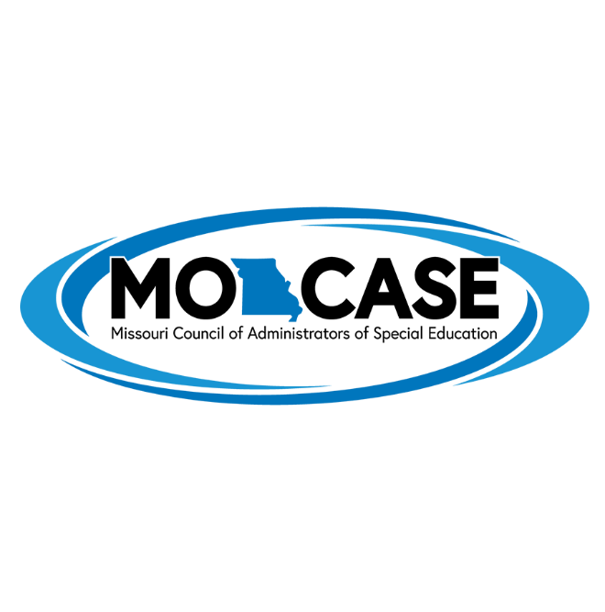

MTSS Implementation Award

This award, which was first presented in 2016, is given in recognition of district-level implementation of a systematic multi-tier system of supports (MTSS) for students. Up to 10 districts will be recognized at the annual MO-CASE Awards Banquet. Districts may apply by completing an online survey about essential components of a viable MTSS.

